The magistracy has the opportunity to continue education in the postgraduate PhD-doctoral studies.

Employment:

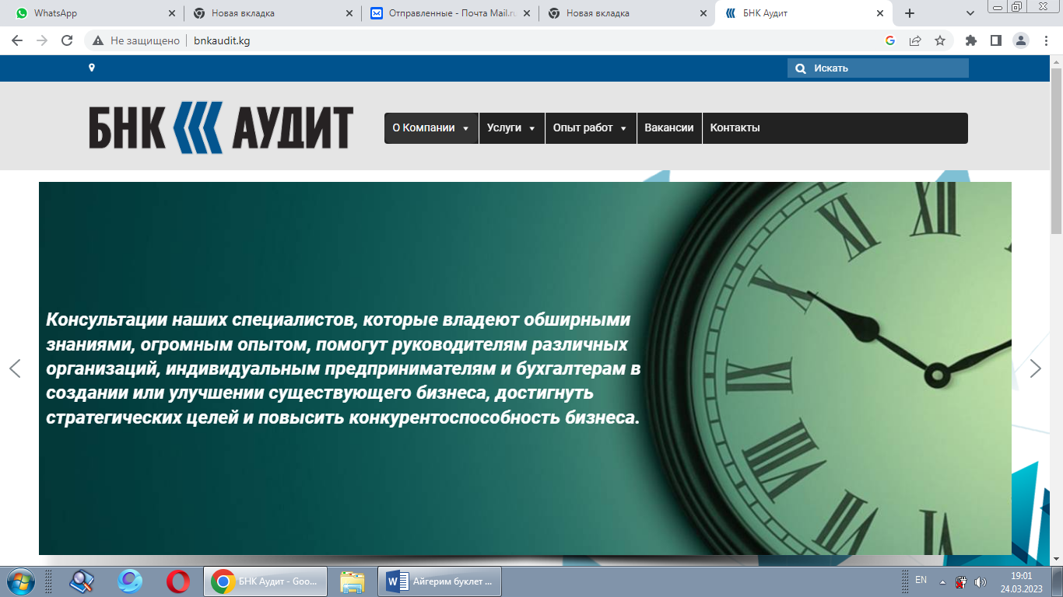




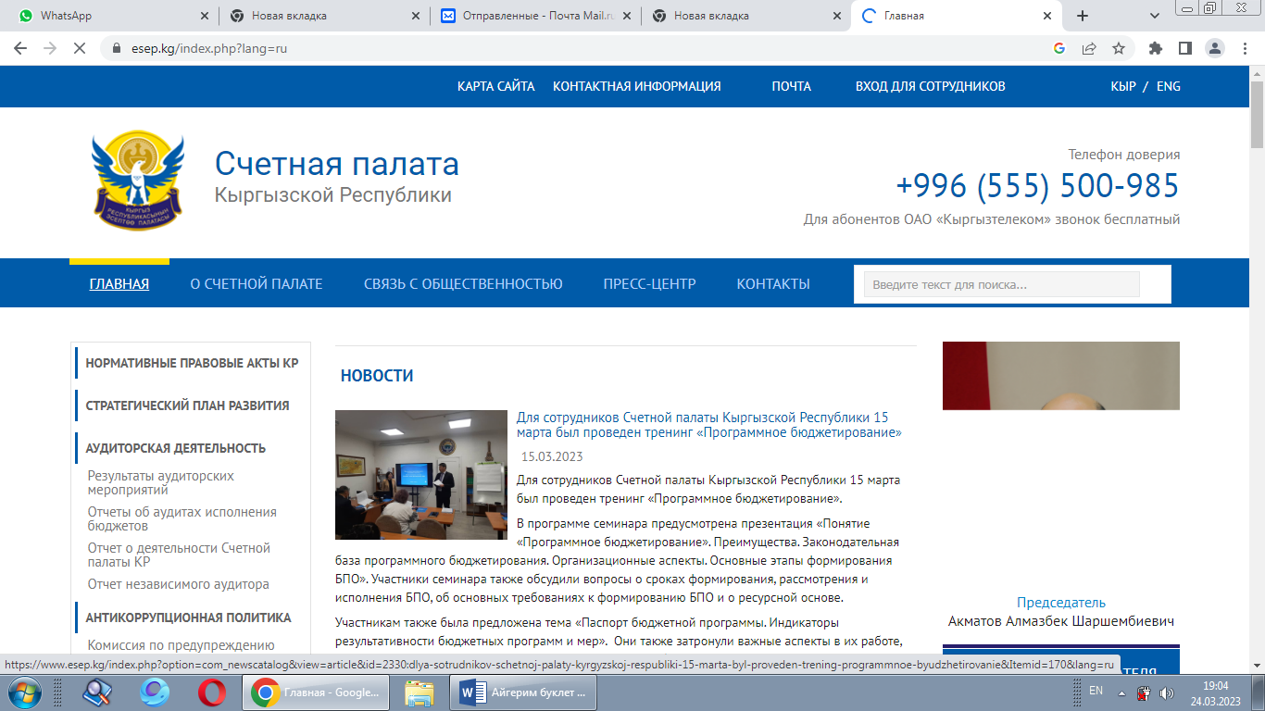







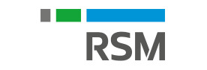



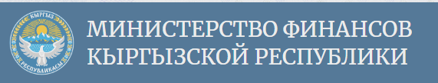



Higher School of Economics and Business

Department "Economic security and
marketing"

Rep. Elchibaeva A.Z
Тел.0702 64 70 85

Master Program
"Audit and financial consulting"
Persons who have successfully completed their studies in one of the main educational programs of a bachelor or specialist and have a diploma of higher education have the right to study under master's programs.
Form of education - full-time, part-time
Upon completion of training, graduates are issued a master's degree of the state sample.
Audit is an integral element of the market infrastructure. Auditing activities involve a wide range of services in the field of accounting, control, taxes and finance, provided by highly qualified specialists. Internal auditors and internal controllers are extremely in demand. Such specialists are trained within the framework of the master's program "Audit and financial consulting" direction 580100 "Economics".
The purpose of the master's program is to train specialists in the field of audit business, internal control and audit, as well as the introduction of modern approaches and methods of control in the activities of business entities and state financial control bodies.

The program involves the study of special and professionally significant disciplines at an advanced level:
• Outsourcing of accounting services
• Organization and standardization of audit activities
• Internal corporate control and fraud audit
• Forensic accounting expertise
• Internal audit
• Performance audit
• Computerization of accounting and auditing, etc.
Much attention is paid to the study of problems of taxation and tax audit, the use of software in auditing and consulting.
The final stage of studying in the master's program will be the preparation and defense of a master's thesis on one of the urgent problems of audit, internal control and financial consulting.
The master's program "Audit and Financial Consulting" may be of interest to bachelors of economics, graduates of economic, legal and other universities, as well as specialists with experience in the audit business, in state financial control bodies, as well as in control, financial and accounting departments of business entities.

Master's degree graduates of the program "Audit and Financial Consulting" will be in demand as external and internal auditors, specialists of regulatory government bodies, heads of various departments and projects in the audit and consulting business, tax consultants, experts in institutions of judicial accounting expertise, teachers and researchers in the field of control and audit. The breadth of coverage of the studied problems all

